Home Assignment – Week 3

Day 1:

Extension:
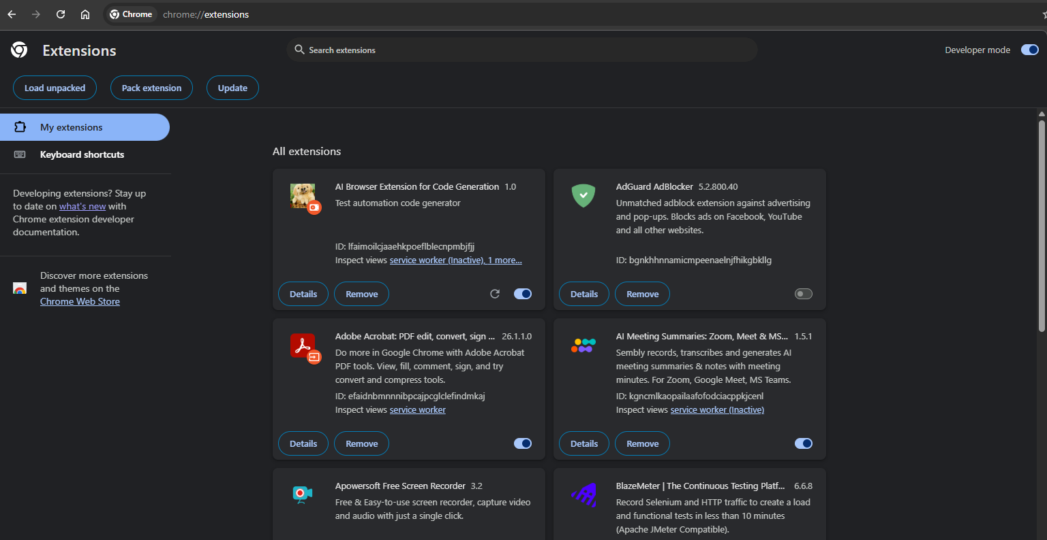
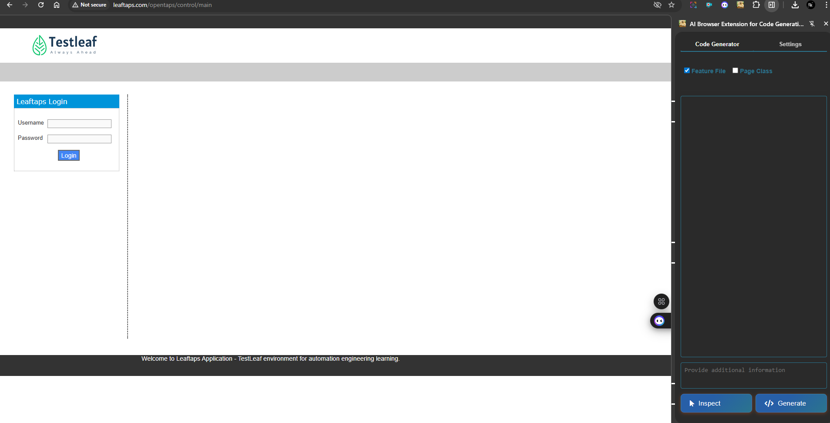

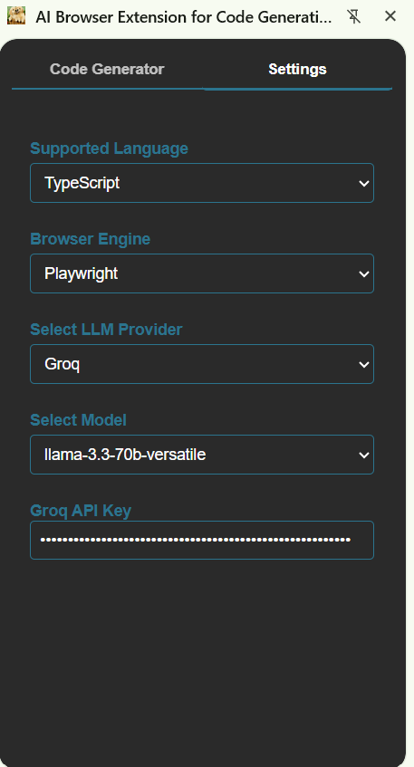

Feature: Login to KAG CLOUD Application

Scenario Outline: Successful login with valid credentials
Given I open the KAG CLOUD login page
When I type "<username>" into the Username field
And I type "<password>" into the Password field
And I click the Login button
Then I should be logged in successfully

Examples:
| username | password |
| "siva@gmail.com" | "siva123" |
| "ravi@gmail.com" | "ravi123" |
| "kumar@gmail.com" | "kumar123" |

import { Given, When, Then, Before, After } from '@cucumber/cucumber';
import { Browser, Page, chromium, expect } from '@playwright/test';

let browser: Browser;
let page: Page;

Before(async function() {
browser = await chromium.launch({ headless: false });
page = await browser.newPage();
});

After(async function() {
await browser.close();
});

Given('I open the KAG CLOUD login page', async function() {
await page.goto('http://www.kagcloud.in/cloud/auth/dclogin?ReturnUrl=%2fcloud%2fcustomer%2favailability');
});

When('I type {string} into the Username field', async function(username: string) {
await page.locator('#username').fill(username);
});

When('I type {string} into the Password field', async function(password: string) {
await page.locator('#password').fill(password);
});

When('I click the Login button', async function() {
await page.locator('button:has-text("Log In")').click();
});

Then('I should be logged in successfully', async function() {
// Since the provided HTML does not contain a success message,
// we will check if the login form is no longer visible after clicking the login button
await expect(page.locator('#login_form')).not.toBeVisible();
});

Bug magnet Extension:

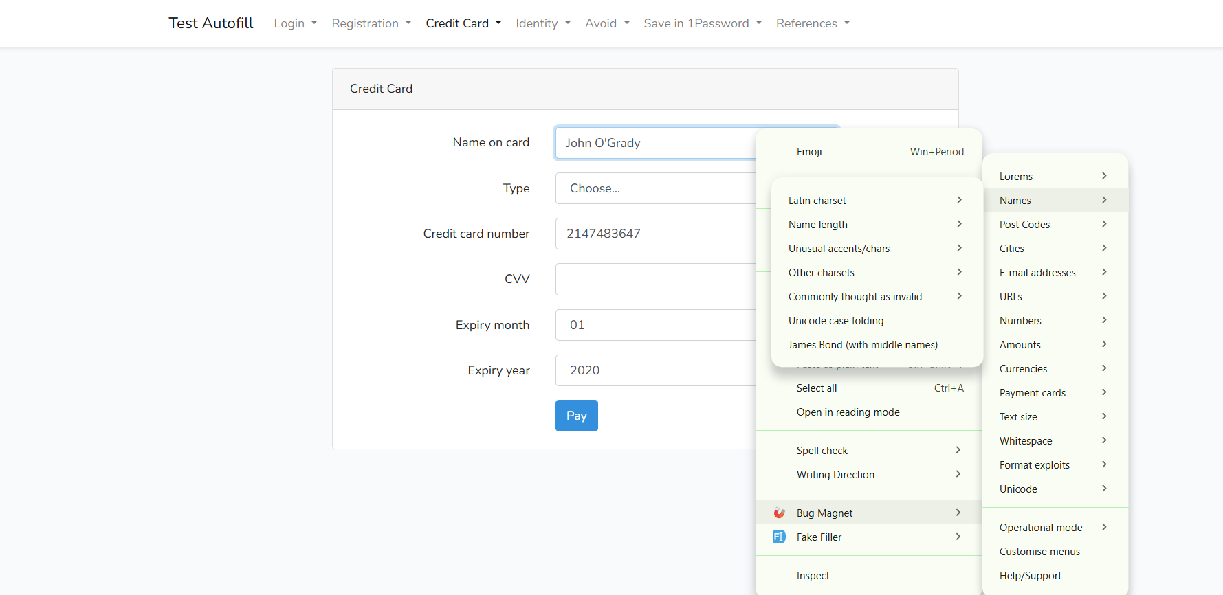

Grammarly:

With errors:
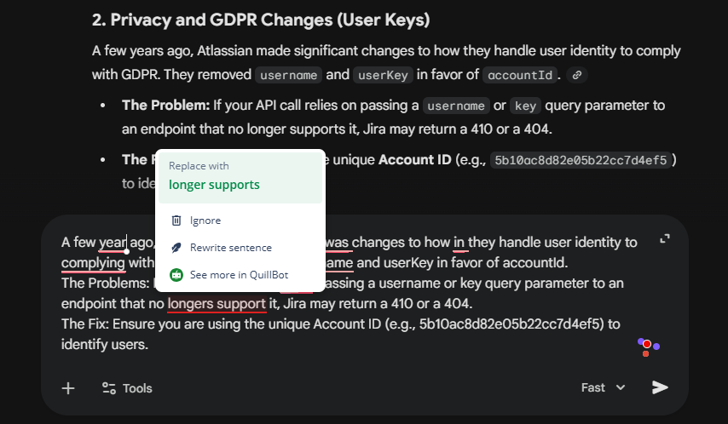
Corrected:
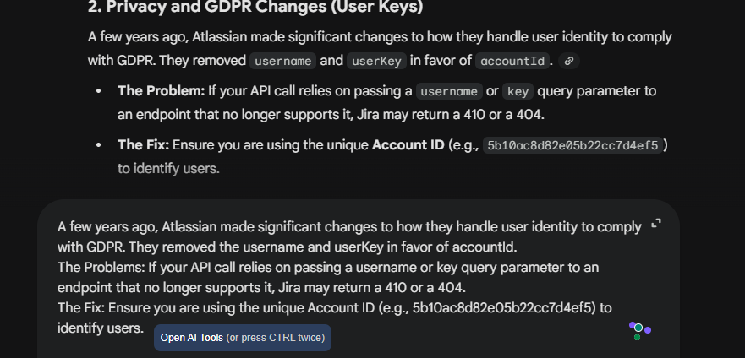

Day 2:
Integrate the Jira with the existing user story into the testcase generator codebase
This is the overall requirement and Hint for Jira integration Assignment.
Requirements:
- Add a “Connect Jira” button in the UI page to establish a connection (Base URL, email, API token).
- After successful connection, show a dropdown listing all user stories.
- Add a “Link Story” button that fetches story details (Title, Description, Acceptance Criteria).

- Add backend connectivity to Jira.
- Once connected, populate the stories; on Link Story, display the details.

Assignment 2:
Add a download button in UI with formats like XLSX, PDF, CSV.
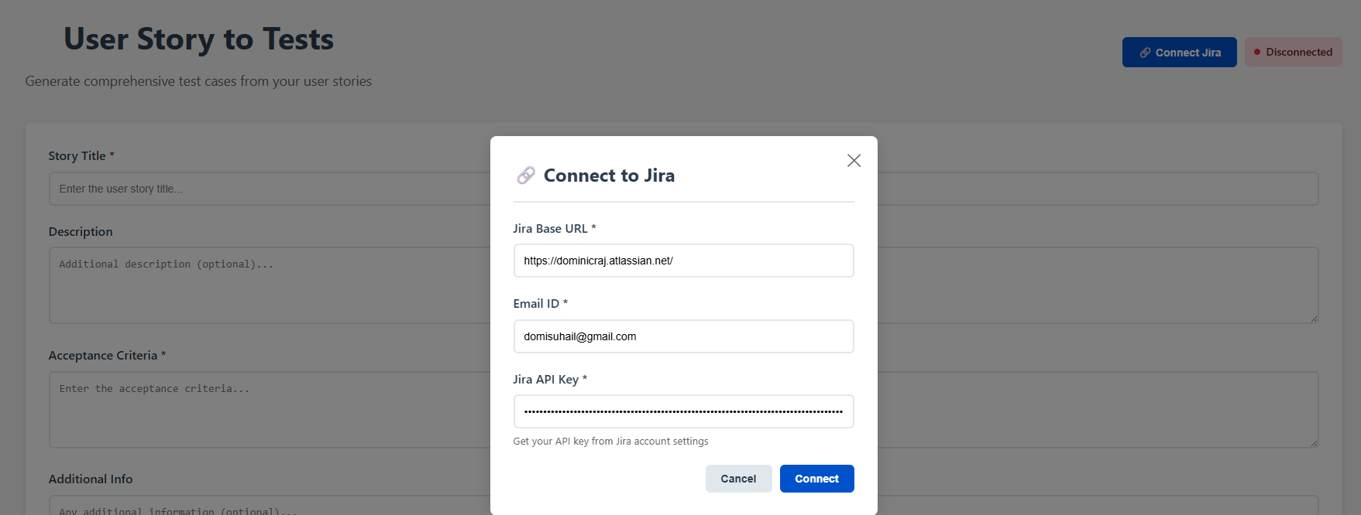

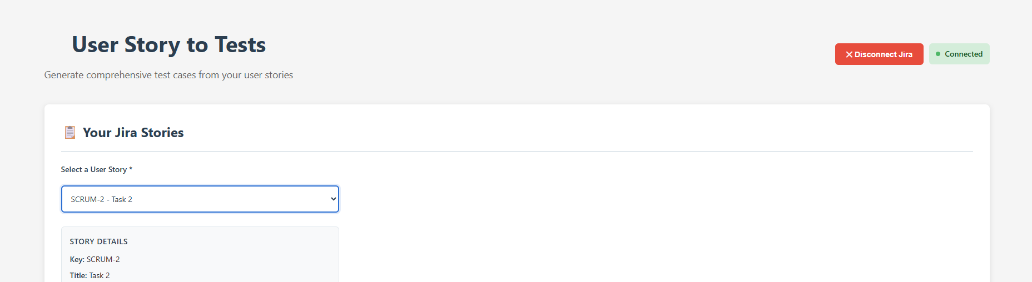

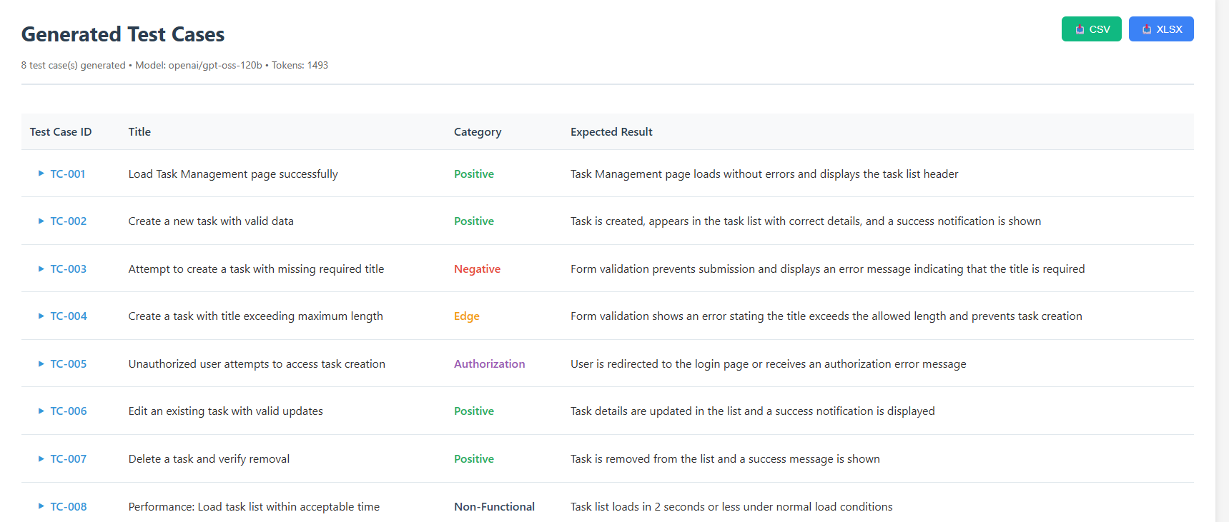

Downloaded:
Downloaded File:
